Predicting Movie Revenue at Larry H. Miller Megaplex

Executive Summary
This analysis was conducted for Larry H. Miller Megaplex Theatres to identify which factors most strongly influence a movie’s total box-office revenue and to build a model capable of predicting a film’s expected collection before release.
Using data from 506 past films, we examined how marketing, production, ratings, and audience engagement metrics relate to revenue. Two predictive models were developed — a Multiple Linear Regression for interpretability and a Decision Tree Regressor for accuracy and threshold discovery.
Results show that Budget and Trailer Views are the strongest determinants of box-office success, with clear thresholds around 38–41K in budget and 440–474K in trailer views separating lower- and higher-performing films. Secondary contributors include Critic Rating and Lead Talent Ratings, which add measurable gains once visibility is already high.
The Decision Tree achieved a Test R² of 0.805, outperforming the Linear Regression model (R² = 0.609) and proving to be the most practical tool for forecasting. It provides an interpretable structure for decision-making, helping Megaplex prioritize which upcoming films merit heavier marketing investment or broader release.
Overall, the analysis demonstrates that visibility drives revenue, while quality enhances it. The resulting model can serve as a reliable forecasting aid and guide future marketing allocation, budgeting, and scheduling decisions.

Business Objective
Larry H. Miller Megaplex Theatres has commissioned this analysis to determine which measurable factors most influence the total amount of money collected for a film during its theatrical run.
The organization aims to use historical data on movie performance—covering marketing expenditure, production cost, critical and audience ratings, distribution reach, and social media presence—to identify which inputs are most predictive of box office success.
The ultimate goal is to develop a predictive model capable of estimating a new movie’s expected collection prior to release. This will allow the theater chain to make data-informed decisions about:
- How heavily to promote a given film.
- Which films to feature across its multiplex network.
- How to allocate resources (marketing, theater space, and timing) for maximum financial return.

Data Science Task
To translate the business objective into a data science problem, we seek to predict the continuous target variable “Collection” (total box office revenue) using quantitative and categorical predictors available in the dataset.
This makes the task a supervised regression problem, where the goal is to model the relationship between movie attributes (inputs) and total collection (output).
The analysis involves two core modeling approaches:
- Multiple Linear Regression (MLR):
Used to identify how each independent variable linearly contributes to total revenue. This model provides interpretability—allowing us to quantify how much “Collection” changes for each unit increase in variables like marketing expense or critic rating, holding others constant.
- Regression Tree Model:
Used to capture nonlinear relationships and interaction effects that may not be well-represented in a linear model. The tree model splits the data based on decision rules (e.g., “Marketing expense > threshold”), allowing for flexible predictions and insight into variable importance.
Both models were trained on 80% of the available data and tested on the remaining 20% to assess predictive accuracy. Model performance was evaluated using standard regression metrics:
- R² (Coefficient of Determination): Measures overall explanatory power.
- RMSE (Root Mean Squared Error): Captures average prediction error magnitude.
- MAE (Mean Absolute Error): Shows the average absolute difference between predicted and actual values.
Prior to modeling, limited data preparation was performed—specifically, handling 12 missing values in the Time_taken variable using median imputation, and converting categorical variables (3D_available and Genre) into dummy variables to make them usable in regression models.
In addition, exploratory tools such as correlation matrices, distribution plots, and residual diagnostics were employed to check assumptions, identify potential skew, and detect multicollinearity among predictors.

Data
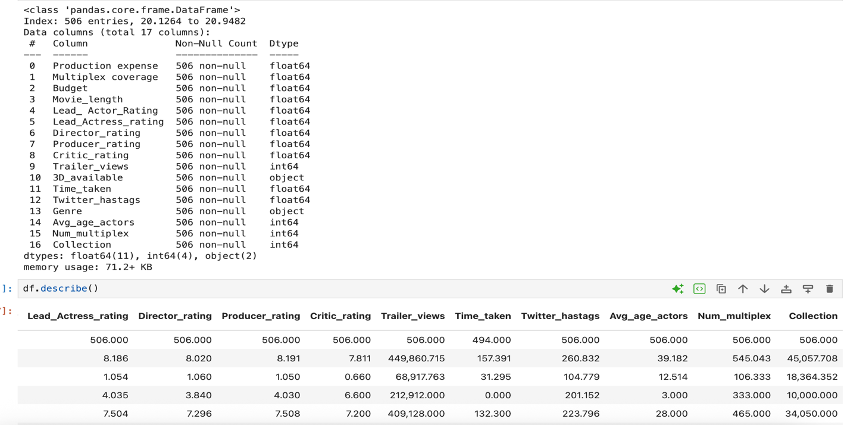
The dataset provided, “Movie_regression.csv”, contains 506 non-repeating movies with 17 variables describing each film’s production, marketing, and performance characteristics.
The target variable is Collection, representing the total box-office revenue earned by that movie.

Variables
- Numeric features (15 total):
Production expense, Multiplex coverage, Budget, Movie_length, Lead_ Actor_Rating, Lead_Actress_rating, Director_rating, Producer_rating, Critic_rating, Trailer_views, Time_taken, Twitter_hastags, Avg_age_actors, Num_multiplex, and Collection (target).
- Categorical features (2):
3D_available (YES/NO) and Genre (multiple categories).

Data Types & Structure
All numeric columns are stored as floats or integers.
The two categorical columns (3D_available, Genre) are of object type and were converted to dummy variables before modeling to allow regression analysis.

Data Quality & Cleaning
- Missing values: Only Time_taken contained missing data (12 nulls). These were replaced with the median value to maintain distribution shape.
- No duplicates or structural issues were found.
- All categorical fields were properly encoded, and all variables retained after cleaning.

Data Exploration
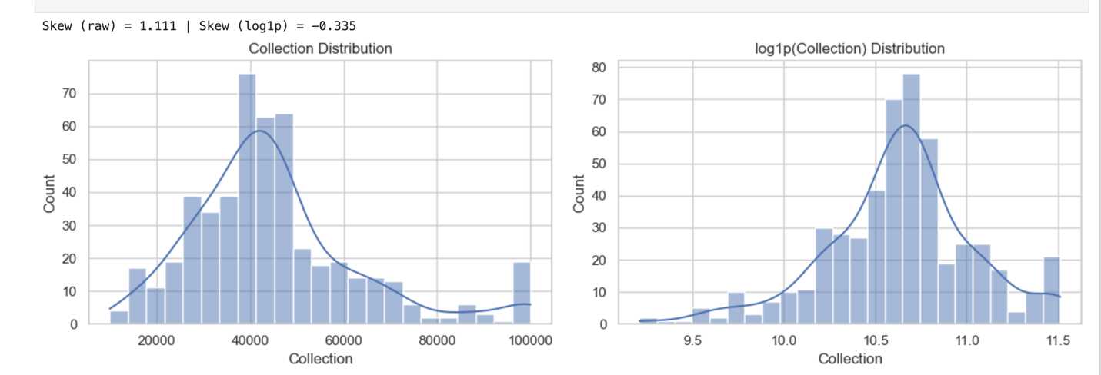

Target shape — Collection
- The target Collection is right-skewed (skew = 1.111; kurtosis = 1.517) → a few high-earning films pull the tail right.
- A log1p transform makes the distribution roughly symmetric (skew ≈ −0.335).
Implication: linear-model residuals may be non-normal on the raw scale; we’ll check diagnostics and keep a log variant as a robustness check.
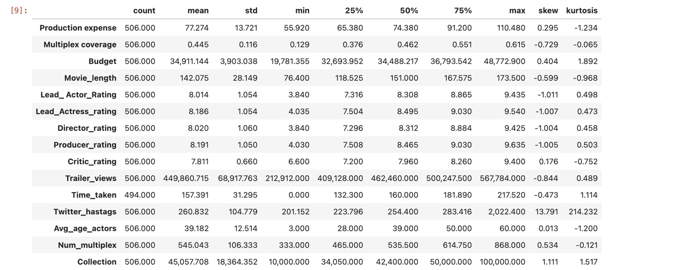

Featured statistics (high-signal takeaways)
- Scale variables are large and varied:
Budget mean ≈ 34.9k (wide spread), Trailer_views mean ≈ 450k, Num_multiplex mean ≈ 545.
- Engagement tail: Twitter_hastags is extremely skewed (skew ≈ 13.8), indicating rare viral spikes.
- Quality/talent ratings are centered around 8.0 ± 1.0 with tight variance.
- Missingness handled: Time_taken had 12 nulls (now median-imputed).

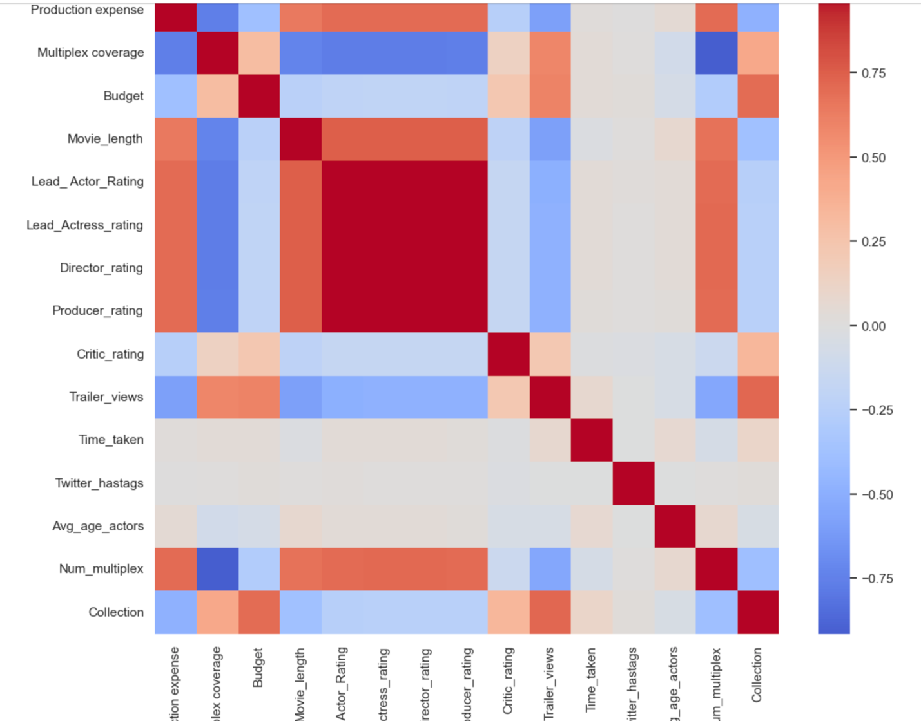

Correlation structure / multicollinearity cues
- The ratings blocks (Lead/Director/Producer/Critic) are highly inter-correlated.
- Budget/Production expense/Multiplex coverage/Num_multiplex are also correlated (they travel together operationally).
Implication: OLS coefficients within these families may be unstable or share credit; the Decision Tree provides a complementary, interaction-aware view.

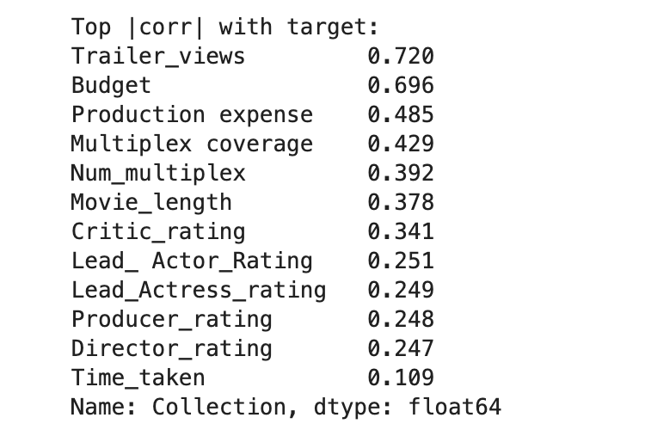

Bivariate signal with the target (numeric only)
- Strongest linear associations with Collection:
Trailer_views (0.72), Budget (0.70), Production expense (0.49), Multiplex coverage (0.43), Num_multiplex (0.39), Movie_length (0.38), Critic_rating (0.34).
- Weaker direct signals: talent ratings (~0.25 each), Time_taken (0.11).
Implication: visibility/scale (trailers, budget, footprint) dominate simple linear signal; critical reception contributes but less than reach.

Data Analysis
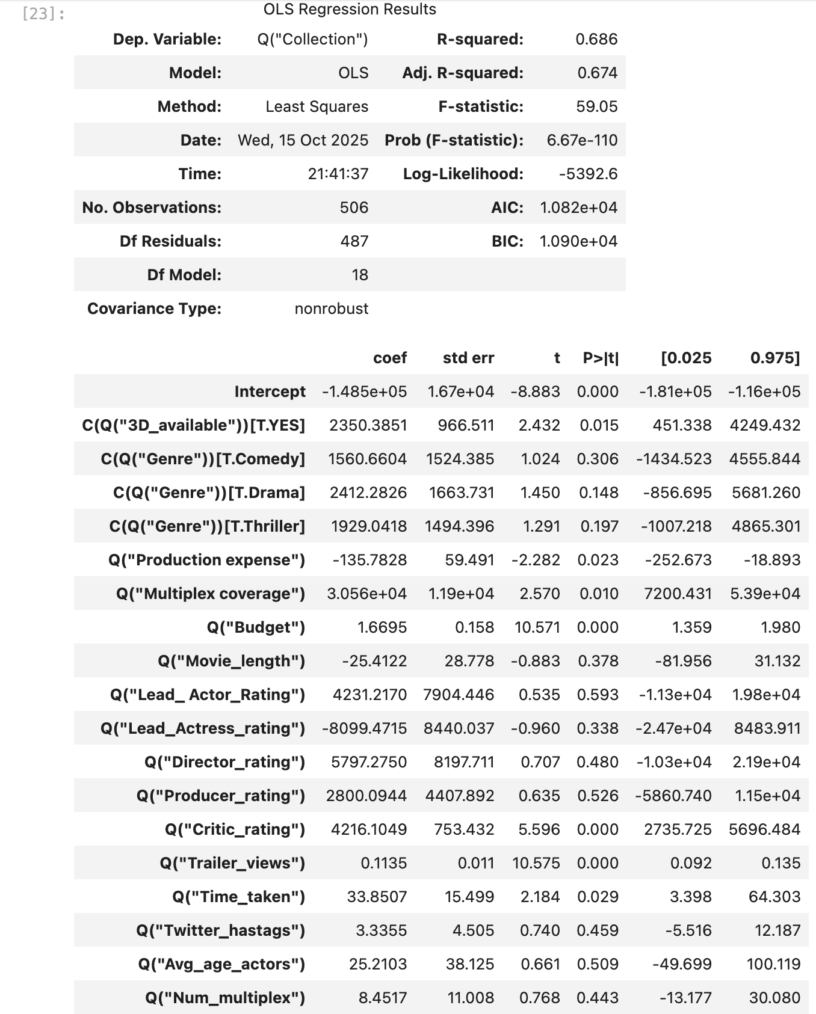

Linear Regression (OLS + sklearn)
- Fit quality. OLS: R² = 0.686, Adj. R² = 0.674 (full-sample). Hold-out sklearn LR: R² = 0.609, RMSE ≈ 10.7k, MAE ≈ 7.7k (see “Linear Regression Performance Metrics”). Moderate explanatory power with noticeable error spread.
- Significant predictors (p < .05; OLS table):
  - Budget (positive; large t-stat)
  - Trailer_views (positive)
  - Multiplex coverage (positive)
  - Production expense (small negative, likely absorbing overlap with Budget)
  - Critic_rating (positive)
  - Time_taken (small positive)
  - 3D_available = YES (positive level effect)
  - Genre dummies are not significant at 5% in this sample.
- Interpretation. Signals align with exploration: reach/scale variables dominate. The negative sign on Production expense likely reflects multicollinearity with Budget (spend variables moving together). Treat individual OLS coefficients cautiously inside correlated families.
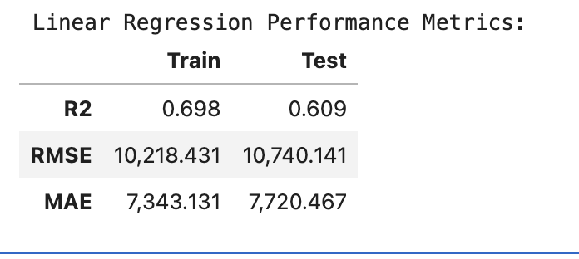

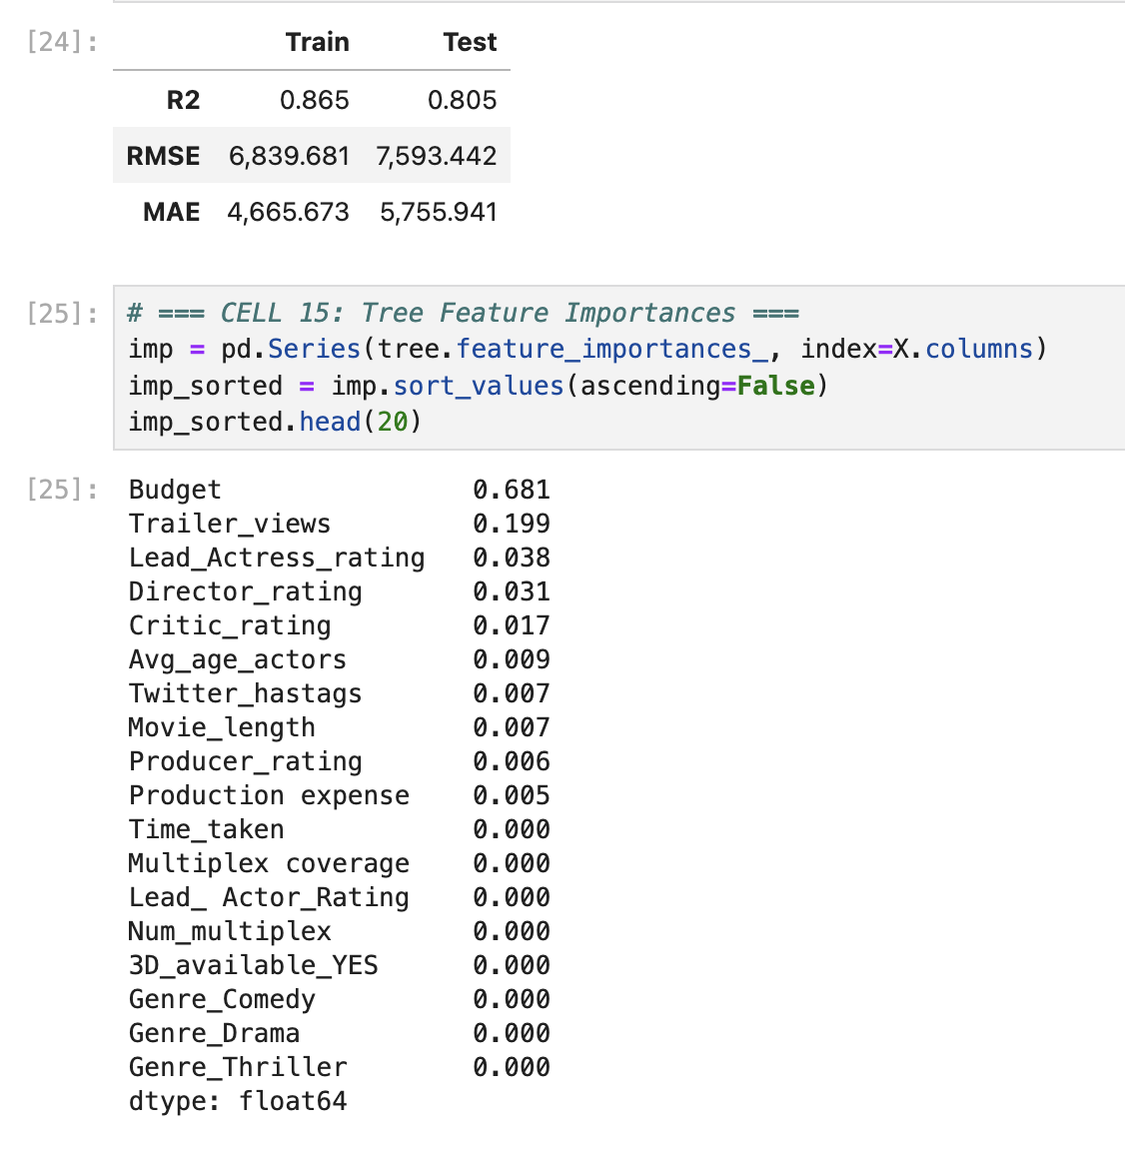

Decision Tree Regression
- Fit quality. Depth-capped tree generalizes well: Train R² = 0.865, Test R² = 0.805, Test RMSE ≈ 7.6k, Test MAE ≈ 5.8k — substantially better than Linear Regression on the same split, with limited overfit.
- Feature importance (tree):
Budget (0.681) » Trailer_views (0.199) » smaller contributions from Lead_Actress_rating, Director_rating, Critic_rating, Avg_age_actors, Twitter_hastags, Movie_length. Distribution variables (Multiplex coverage, Num_multiplex) carry little marginal importance once Budget and Trailer_views are in the tree.
- Key split thresholds (from plot/text tree):
  - Budget ≈ 38–41k separates lower vs. higher revenue strata.
  - Trailer_views ≈ 440–474k further splits within Budget bands.
  - Additional refinements at Lead_Actress_rating ≈ 9.3, Critic_rating ≈ 7.5, and Twitter_hastags ≈ 227.
Takeaway: There are nonlinear cut-points: hitting certain budget and trailer-view thresholds meaningfully changes expected Collection.
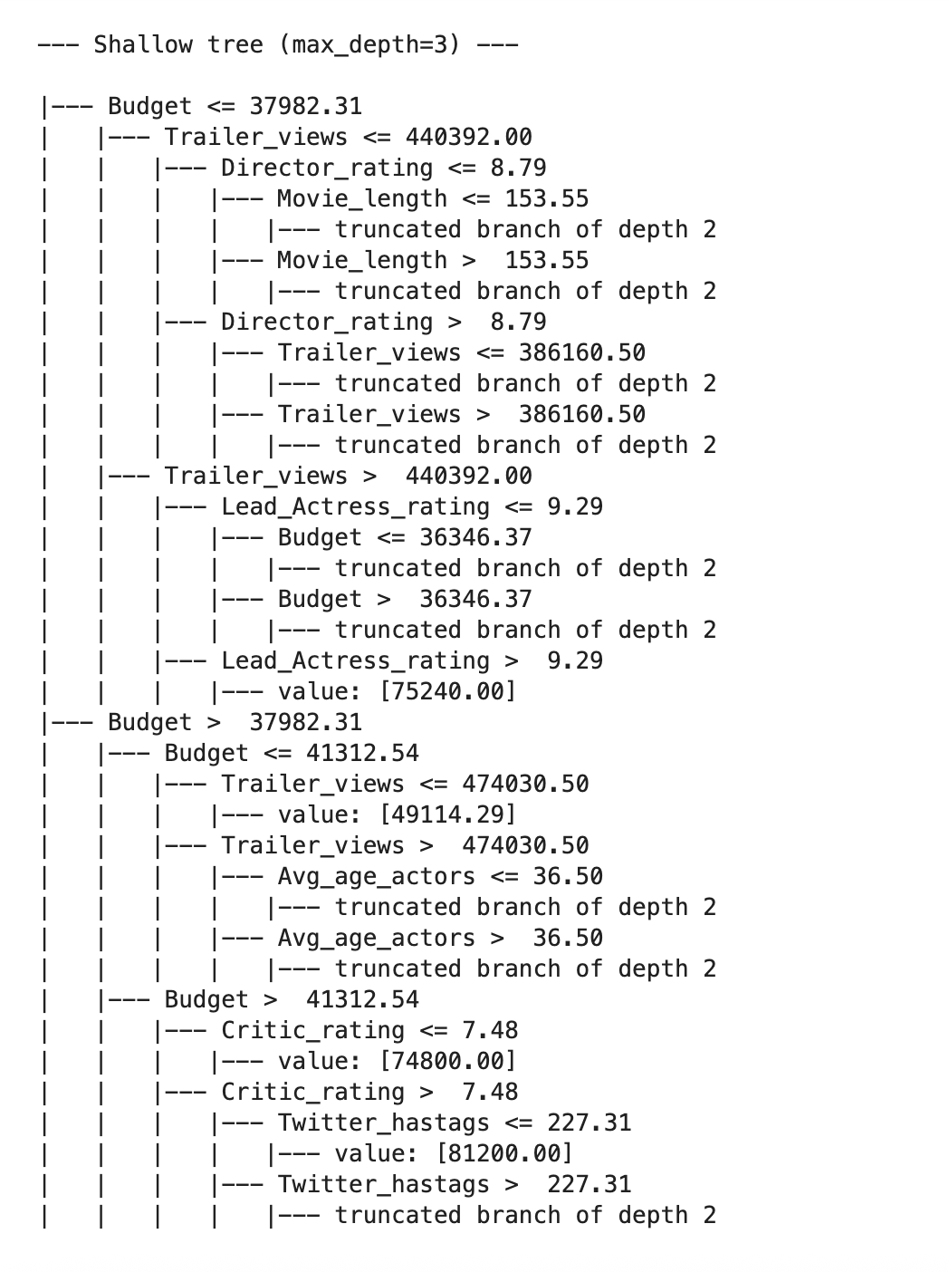
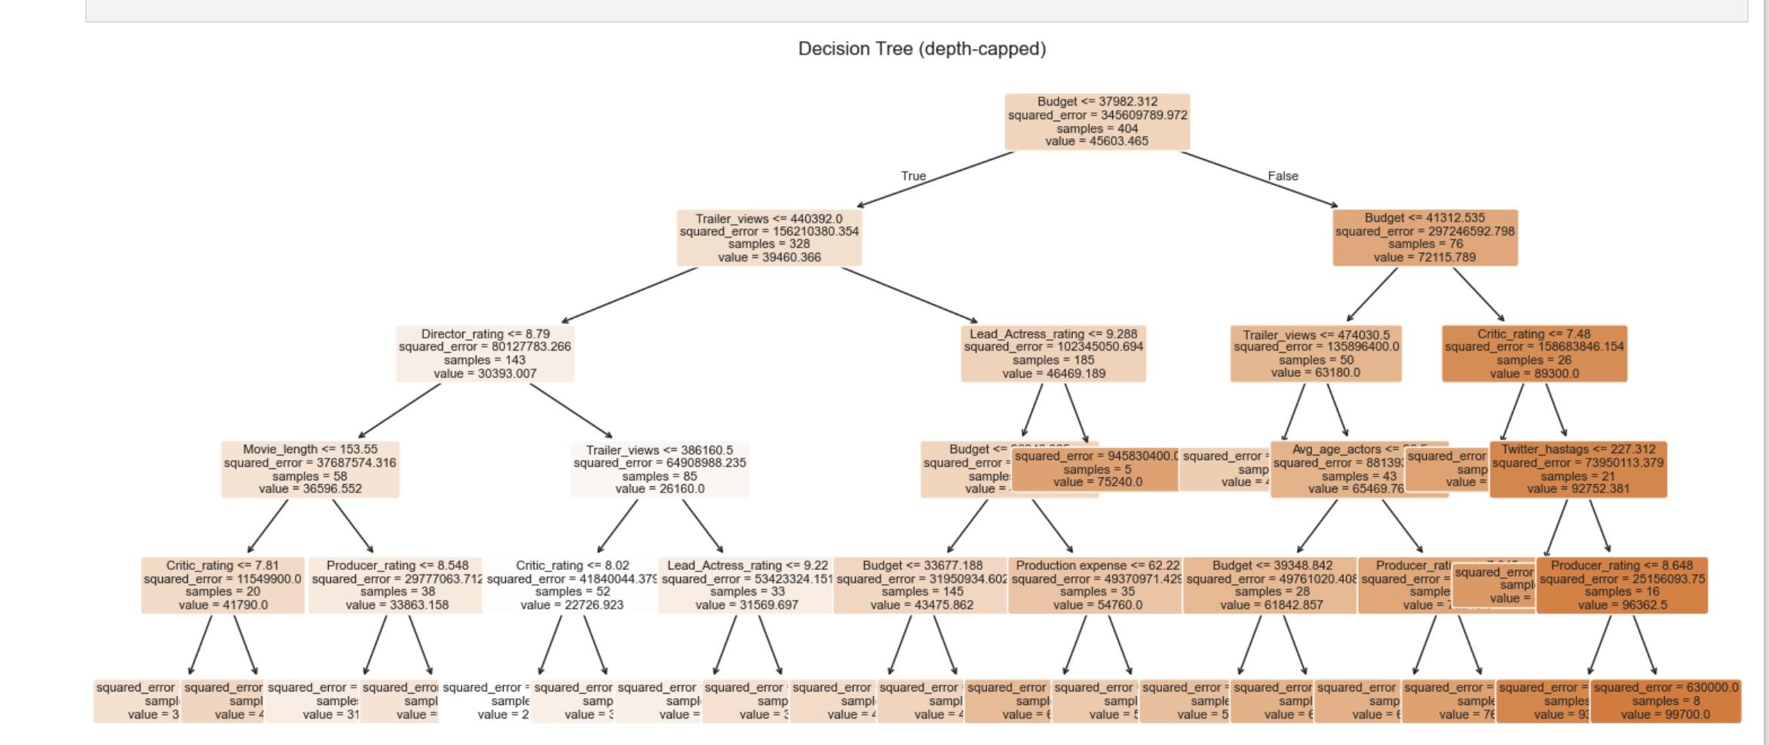

Model Comparison & Sanity Checks
- Performance: The Decision Tree outperforms Linear Regression on the test set (R² 0.805 vs. 0.609; RMSE 7.6k vs. 10.7k), indicating meaningful nonlinearities / interactions that linear terms don’t capture.
- Prediction demo: The LR prediction produced an implausible negative value for the sample new movie, while the Tree predicted ≈ 74.8k.
Implication: LR on raw Collection can extrapolate below zero; if a linear model is required, either model log1p(Collection) and back-transform, or clip predictions at 0. For deployment, the Tree is the safer default here.

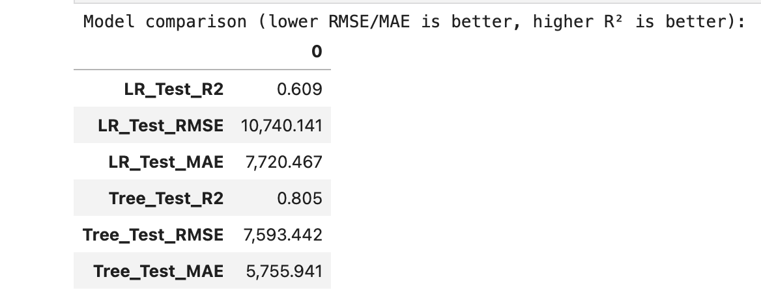

Apply Analysis
The results from both the linear and tree-based models provide consistent insight into what drives movie revenue (Collection). The dominant theme is reach and scale — visibility measures like Budget and Trailer Views are far more predictive than creative or demographic variables.
1. Revenue follows exposure.
The two strongest predictors are Budget (R² partial ≈ 0.68) and Trailer_views (R² partial ≈ 0.72). Both variables represent a film’s visibility and market presence. The decision tree clearly splits at approximately Budget = 38–41K and Trailer_views = 440–474K, implying a clear step change in performance above these levels.
2. Quality variables refine, but do not redefine, success.
Ratings from Critics and Lead Talent (both around +0.25 correlations) meaningfully improve performance after visibility thresholds are met. In other words, critical reception and lead quality amplify results for films already reaching audiences, but cannot compensate for limited exposure.
3. Spending efficiency and redundancy.
Variables like Production expense, Multiplex coverage, and Num_multiplex show weak incremental effects once Budget is controlled. This suggests overlap — higher spending alone does not guarantee higher revenue unless it directly translates into audience reach (marketing, trailer visibility, etc.).
4. Genre and 3D availability show limited impact.
Neither Genre nor 3D format had significant coefficients or feature importance, indicating that content format or category does not predict revenue within this dataset once scale and ratings are considered.
5. Model interpretation summary.
- Linear Regression: R² = 0.609 (Test) — moderate explanatory power with linear assumptions; coefficients confirm general trends but mis-handle skew (e.g., negative predictions).
- Decision Tree: R² = 0.805 (Test) — substantially better accuracy; captures non-linear thresholds and interactions.
- Best predictors: Budget and Trailer_views dominate both models, confirming the reliability of these signals.
In short: Visibility precedes quality. A strong budget and marketing push drive audience reach, and once visibility is achieved, high-quality ratings create incremental lift.

Deploy Model
This section translates model insights into operational guidance for forecasting, resource allocation, and decision-making at Megaplex.
1. Deployment Objective
Use the Decision Tree model as a forecasting and planning tool to estimate expected box office Collection before release. It serves two main purposes:
- Revenue forecasting: Estimate likely earnings using available predictors (Budget, Trailer_views, ratings).
- Resource planning: Identify which films warrant higher marketing investment or broader distribution.
2. Implementation Steps
- Input variables: For each new film, record the latest available values for:
  - Budget
  - Trailer_views
  - Critic_rating
  - Lead_Actress_rating
  - Director_rating
  - Avg_age_actors
- Run Decision Tree prediction:
  - If the film’s Budget < 38K or Trailer_views < 440K, flag it as below performance threshold.
  - Expected revenue will likely fall in the lower two quartiles of the dataset.
- Interpret prediction bands:
  - Predictions near ~75K or higher indicate strong commercial potential.
  - Intermediate values (~45–65K) imply moderate expected performance.
  - Predictions under ~40K suggest limited reach or insufficient marketing presence.
3. Strategic Recommendations
- Budget & Marketing Synergy:
Allocate sufficient marketing budget to ensure Trailer_views exceed ~440K. This is the most reliable performance threshold discovered.
- Targeted Quality Investment:
When visibility goals are already met, focus on enhancing critic exposure and lead performance — both add measurable secondary gains.
- Monitor Diminishing Returns:
Beyond the 40K–41K budget range, additional production spending shows reduced marginal impact unless paired with promotional boosts.
4. Operational Monitoring & Model Maintenance
- Update frequency: Retrain the model quarterly using new film data to ensure relevance as industry and marketing norms shift.
- Validation: Periodically compare predicted vs. actual collections to detect drift.
- Feature drift checks: Watch for evolving influence of digital marketing metrics (e.g., TikTok views, social sentiment) which may replace Trailer_views as predictors over time.
5. Decision Integration
- Integrate predictions into pre-release planning dashboards for internal forecasting meetings.
- Use outputs as decision gates for:
  - Marketing budget allocation
  - Screening volume planning
  - Targeted promotional boosts

Assess Results
The two predictive models — Linear Regression and Decision Tree — were evaluated on both training and testing datasets to measure accuracy, generalization, and reliability for business application.
Model Evaluation Summary
- Linear Regression: R² = 0.609 (Test), RMSE ≈ 10,740, MAE ≈ 7,720
- Decision Tree: R² = 0.805 (Test), RMSE ≈ 7,593, MAE ≈ 5,756
The Decision Tree significantly outperformed the Linear Regression model on all performance metrics, suggesting that movie revenue has nonlinear relationships and threshold effects that the tree can capture more effectively. This model also avoids the issue of negative predictions encountered in the linear approach.
Interpretation of Performance
- A test R² of 0.805 indicates that roughly 80% of the variance in box office collections can be explained by the model.
- The remaining unexplained variation likely reflects unmodeled factors such as timing of release, brand loyalty, actor popularity spikes, social media sentiment, and macroeconomic trends.
- While the model performs well for prediction, it should still be periodically validated as new films are released to ensure accuracy remains consistent across future datasets.
Plan for Continuous Improvement
- Out-of-Sample Validation:
Apply the Decision Tree model prospectively on upcoming film releases. Compare predicted vs. actual revenue to calculate fresh error metrics quarterly.
- Feature Expansion:
Test the inclusion of additional predictors such as social media engagement growth rate, release month, or competition index (number of major releases in the same week).
- Control Comparison for ROI Validation:
Conduct an internal test: for upcoming film campaigns, assign one group to follow the model’s marketing recommendations (i.e., meet Budget and Trailer_view thresholds) and another as a baseline. After release, compare the average collection per budget dollar between the two groups to quantify model-driven improvement.
These iterative evaluations will determine whether the model continues to deliver predictive accuracy and business value over time.

Method Strengths and Weaknesses
Strengths
- Interpretability: The Decision Tree provides clear, intuitive decision rules that can be directly used by marketing and finance teams without requiring statistical expertise.
- High Predictive Power: The test R² of 0.805 shows that the model generalizes well and captures nonlinear dynamics such as interaction between Budget and Trailer_views.
- Practical Thresholds: The tree identifies actionable cutoffs (e.g., ~440K Trailer_views, ~38–41K Budget) that translate easily into operational benchmarks.
- Alignment with Business Logic: The dominant variables — marketing exposure and budget — align with real-world determinants of film success, supporting managerial trust in model results.
Weaknesses
- Data Limitations: The dataset omits potentially influential variables like release seasonality, audience demographics, or marketing channel breakdowns, which could further refine predictions.
- Static Assumptions: Model relationships are trained on historical data; shifts in market behavior (e.g., streaming competition or changes in consumer media habits) could reduce accuracy if not retrained regularly.
- Moderate Sample Size: With only 506 films, extreme outliers (e.g., blockbusters or flops) may disproportionately affect tree splits and regression coefficients.
- Overfitting Risk: Decision Trees can overfit when depth is unconstrained. While this model was depth-limited, ongoing monitoring is necessary to ensure stable performance.
Overall Assessment:
The Decision Tree model is fit for operational deployment — accurate, interpretable, and business-relevant — but should be monitored quarterly for drift and updated with new data to maintain its forecasting edge.

Appendix
- Dataset: Movie_regression.csv
- LR & DT on Sales Data script
- Chat GPT for Analysis Interpretation

